Assignment# 1



ADVANCE STATISTICS
Submitted by: Jawad Hassan
Roll No.: 2230-0035

Submitted to:
Dr. Sana
DATE:
7 October 2025

Task1:
6 raw data sets of EKC from Environmental Kuznets Curve — it’s a concept in environmental economics, It shows the relationship between economic growth (income per person) and environmental degradation (like CO₂ emissions, pollution, etc.). Following statistic parameters are to be found: mean, median, variance, standard deviation while plotting a graph histogram:
Sayfa1-GNI per capita, PPP (current international $)
Raw Data:
From year 2000-2022 on Excel
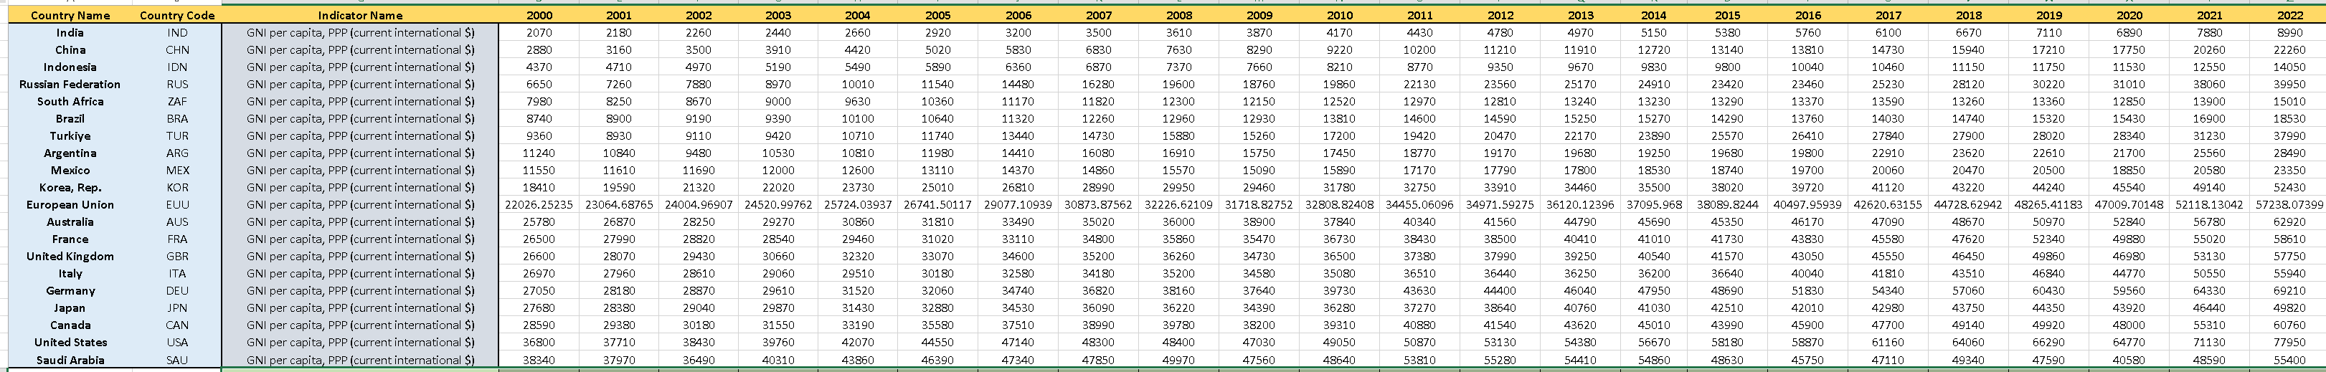

Statistical Analysis:

Graph Plotting:
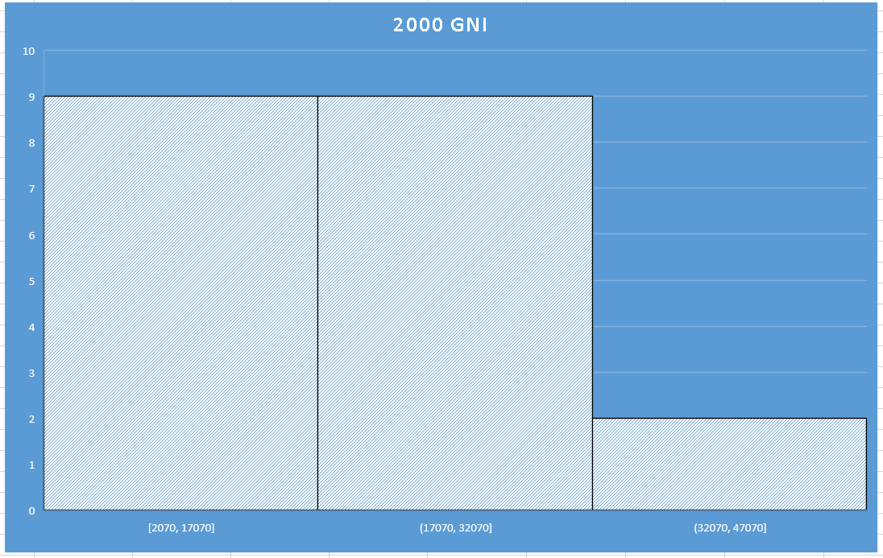
Fig. 1) Year 2000 GNI Histogram
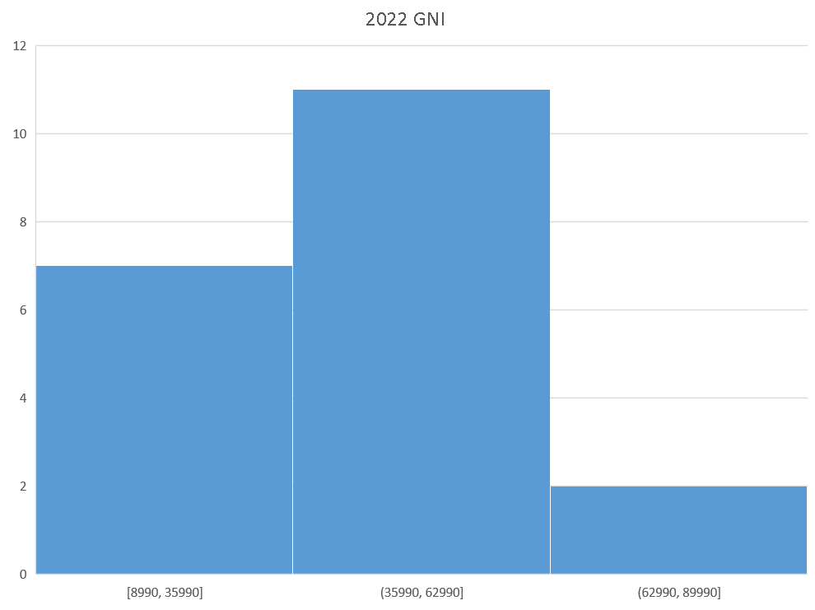
Fig. 2) Year 2022 GNI Histogram

Discussion on Results:
Excel was used as a tool to carry out analysis on the given raw data using some excel formulas on each column which was year attribute for all countries given in the data

Mathematical Formulas:
Mean = AVERAGE(D2:D21)
Median = MEDIAN(D2:D21)
Variance = VAR.P(D2:D21)
Standard Deviation =STDEV.P(D2:D21)

Graphical Analysis:
In fig. 1 the histogram shows the arrangement of data in 3 bars, with first 2 bars equal and last bar is far less than the first two which shows the data is skewed left. Most countries are having gni $2070 – $32070 and only 2 countries GNI is above $32070.
In fig. 2 year 2022 almost latest, gni histogram shows the progress in the GNI as countries are becoming rich day by day and more countries are in the range $35,990- $62990.

Sayfa2- CO2 emissions (metric tons per capita)
Raw Data:
From year 2000-2022 on Excel
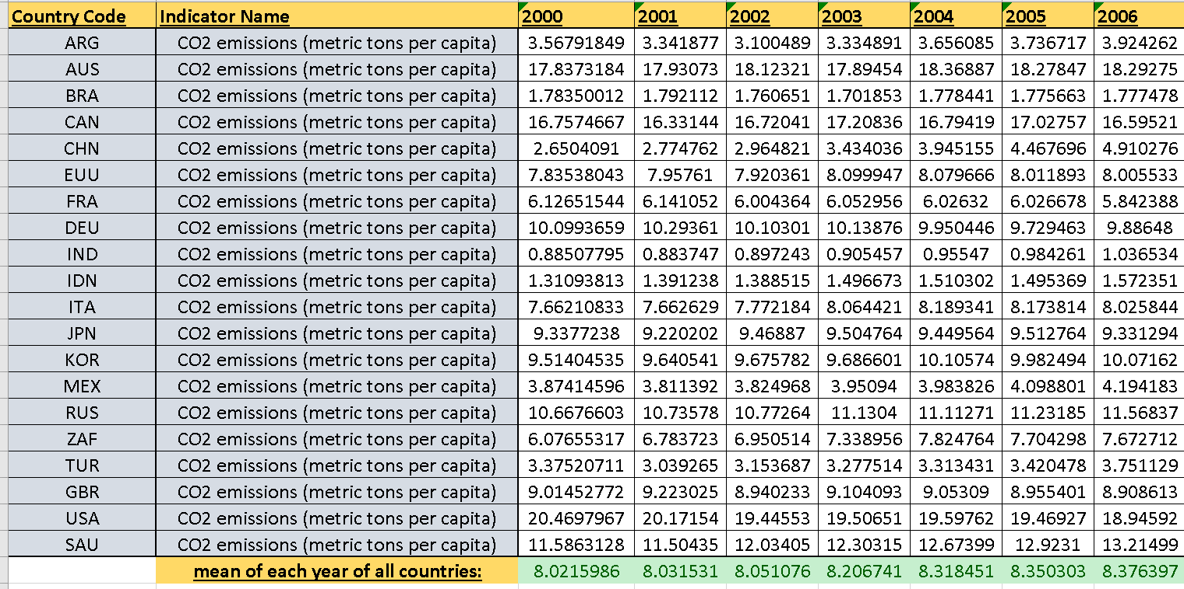

Graph Plotting:
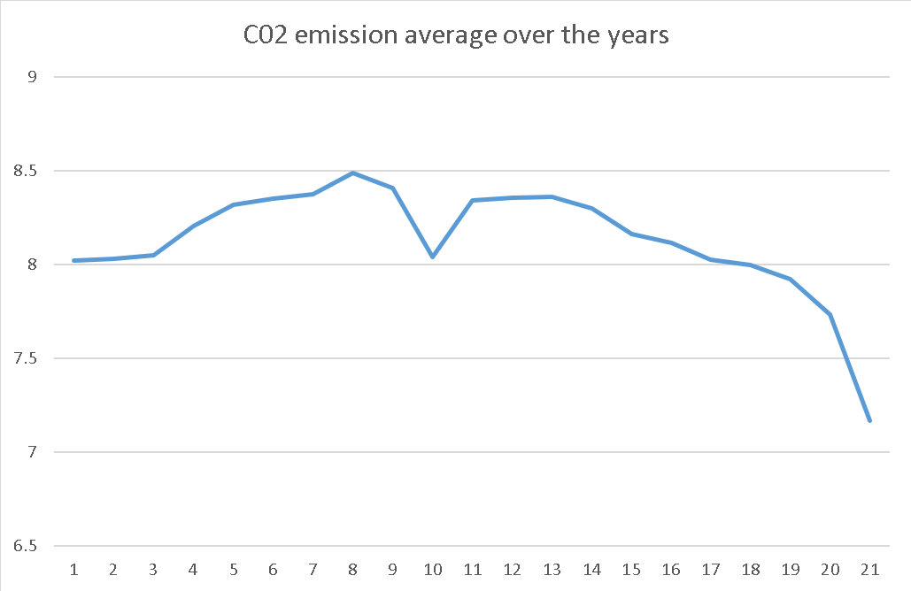
Fig. 3) Mean variation of C02 emission over the years

Discussion on Results:
Excel was used as a tool to carry out analysis on the given raw data using some excel formulas on each column which was year attribute for all countries given in the data

Mathematical Formulas:
Mean = AVERAGE(D2:D21)

Graphical Analysis:
In fig. 3 the line plot has been made using mean of all countries in every year, and it shows first incline in C02 emission rise from 2000-2008 because at first there were less co2 emitting vehicle resources but then later from 2008-2010 a dip was observed because of restrictions from green regulatory authorities across the globe, and now there is a continuous slow decline due to strict green laws imposed.

Sayfa3- GDP (current US$)
Raw Data:
From year 2000-2022 on Excel:

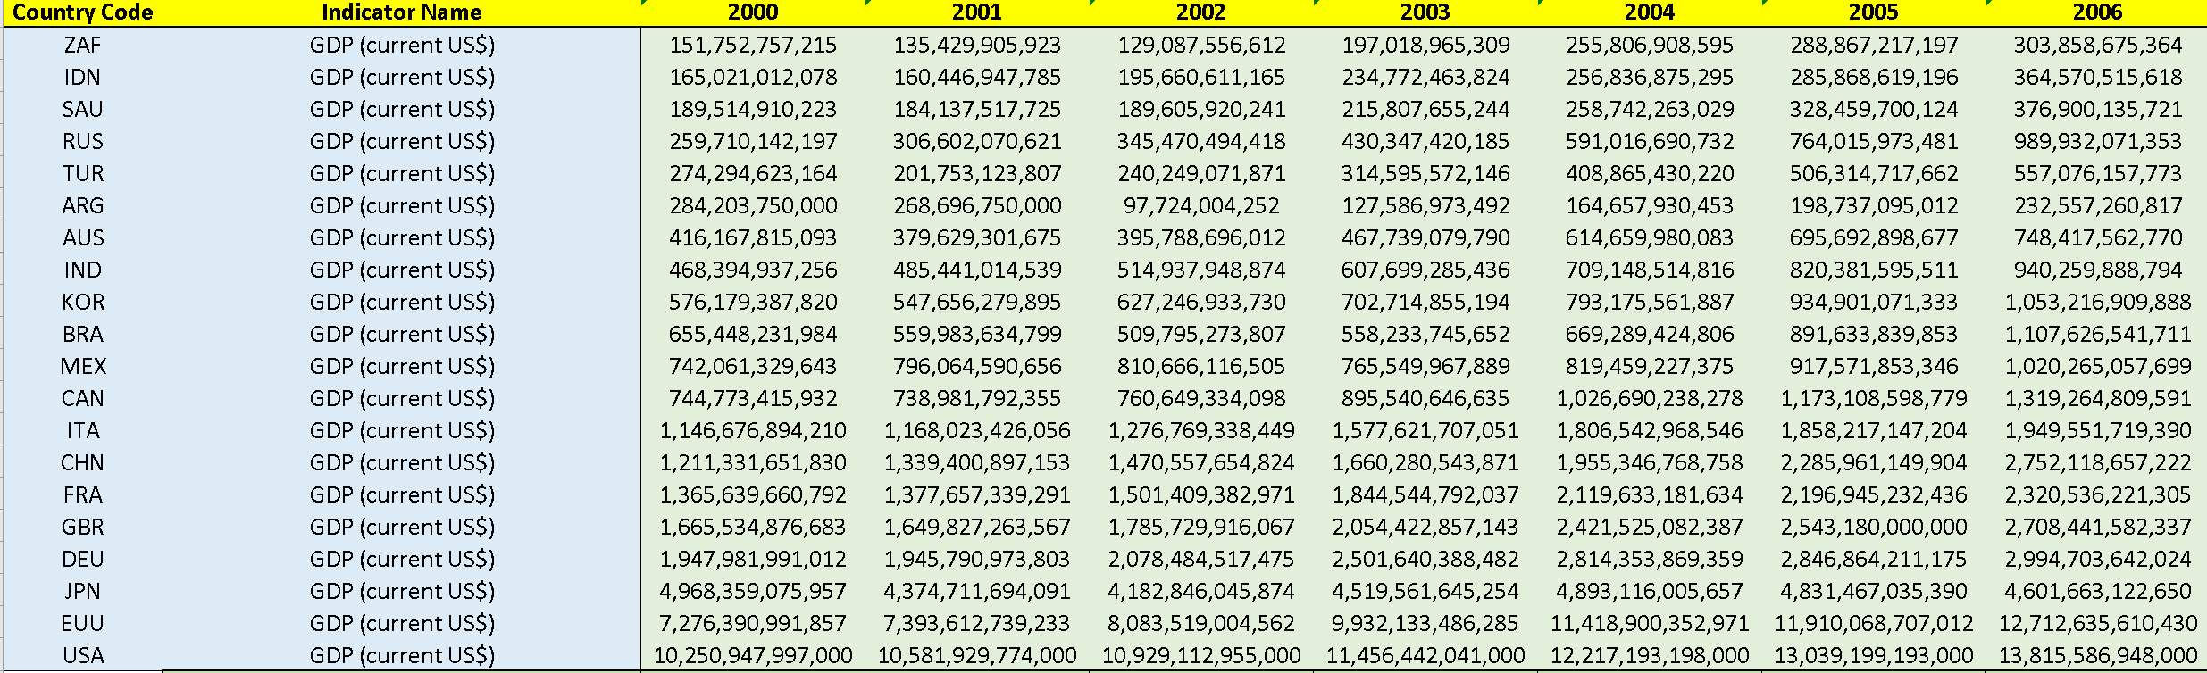

Statistical Analysis:

Graph Plotting:
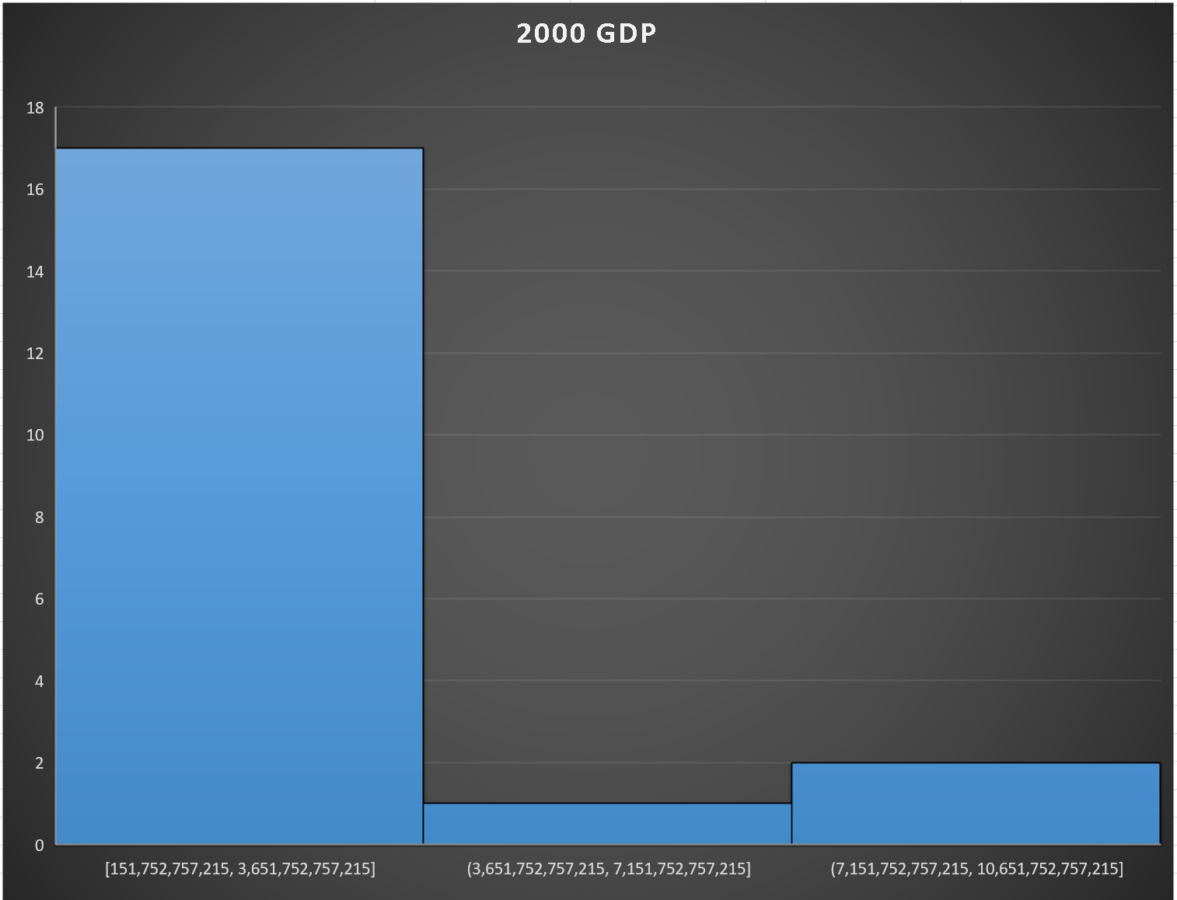
Fig. 4) Year 2000 GDP Histogram

Discussion on Results:
Excel was used as a tool to carry out analysis on the given raw data using some excel formulas on each column which was year attribute for all countries given in the data

Mathematical Formulas:
Mean = AVERAGE(D2:D21)
Median = MEDIAN(D2:D21)
Variance = VAR.P(D2:D21)
Standard Deviation =STDEV.P(D2:D21)

Graphical Analysis:
In fig. 4 the histogram shows the arrangement of data in 3 bars, with first bar being highest showing 17 countries GDP was From range $151 billion – $3.6 trillion and second and third bar is far less than the first which shows the data is skewed left. Third bar shows top two countries with most GDP i.e. European Union and USA.

Sayfa4- GDP growth (annual %)
Raw Data:
From year 2000-2022 on Excel:
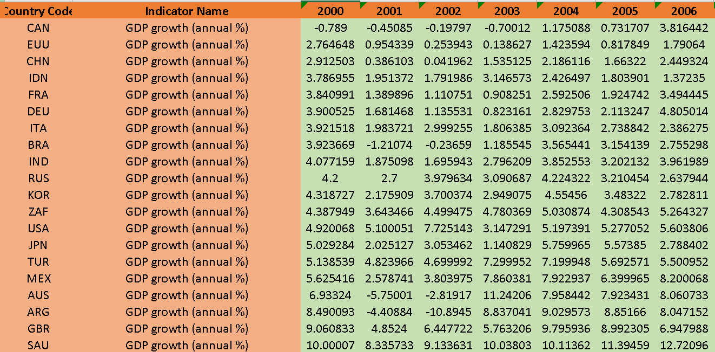

Statistical Analysis:
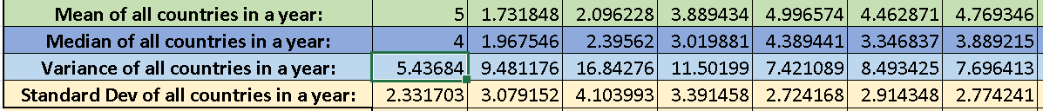

Graph Plotting:
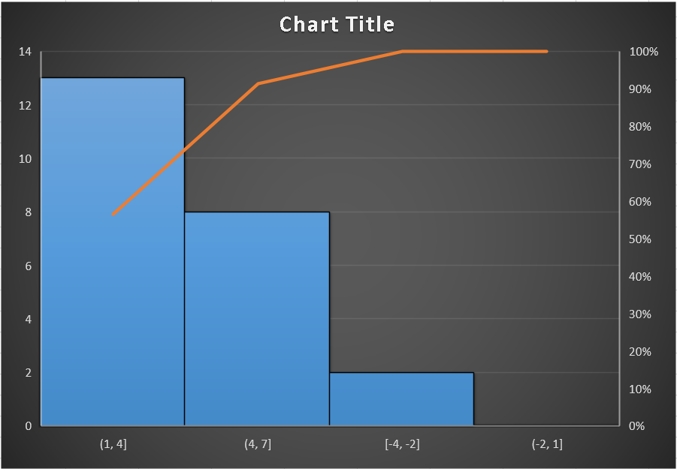
Fig. 5) Annual GDP growth rate mean Histogram of all countries

Discussion on Results:
Excel was used as a tool to carry out analysis on the given raw data using some excel formulas on each column which was year attribute for all countries given in the data

Mathematical Formulas:
Mean = AVERAGE(D2:D21)
Median = MEDIAN(D2:D21)
Variance = VAR.P(D2:D21)
Standard Deviation =STDEV.P(D2:D21)

Graphical Analysis:
In fig. 5 the histogram shows the arrangement of data in 3 bars, with first and second bar being highest showing 13 countries annual GDP mean over the years, from range 1-4 and 4-7 , very few countries in bar 3 shows decline of GDP growth of 2 countires.

Sayfa5- Inflation, GDP deflator (annual %)
Raw Data:
From year 2000-2022 on Excel:
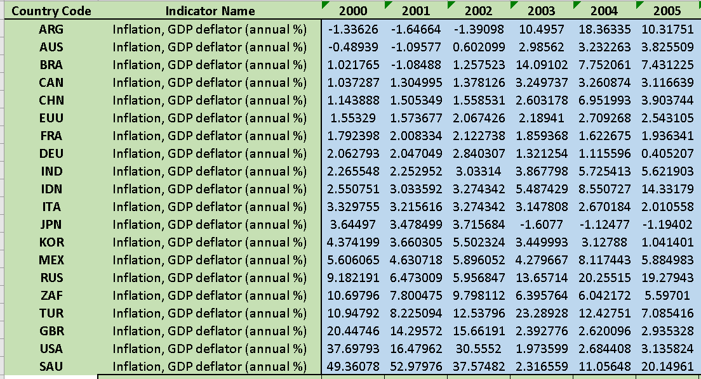
Statistical Analysis:
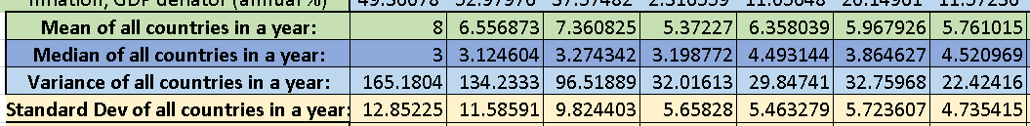

Graph Plotting:
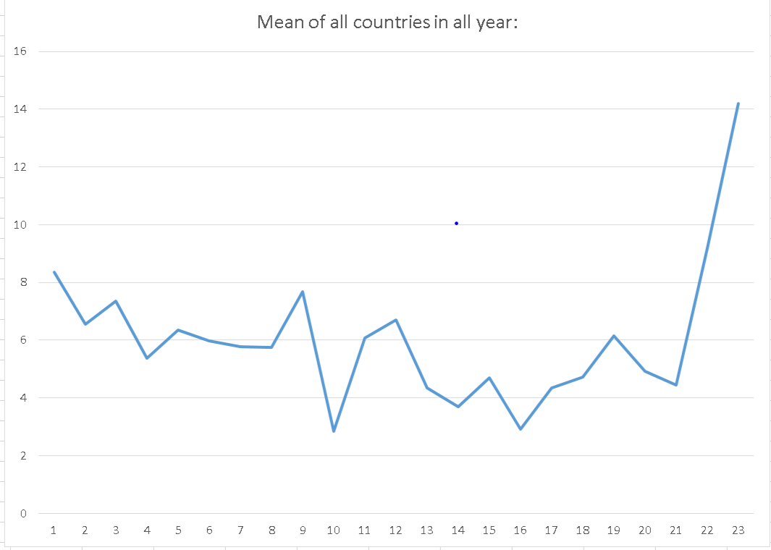

Fig. 6) Annual GDP deflator mean line plot of all countries

Discussion on Results:
Excel was used as a tool to carry out analysis on the given raw data using some excel formulas on each column which was year attribute for all countries given in the data

Mathematical Formulas:
Mean = AVERAGE(D2:D21)
Median = MEDIAN(D2:D21)
Variance = VAR.P(D2:D21)
Standard Deviation =STDEV.P(D2:D21)

Graphical Analysis:
In fig. 6 the line plot shows there was a dip in the inflation in 2010 but then inflation is at its peak from 2020 onwards rising at a very fast rate in all countries.

Sayfa6- Foreign direct investment, net inflows (BoP, current US$)
Raw Data:
From year 2000-2022 on Excel:
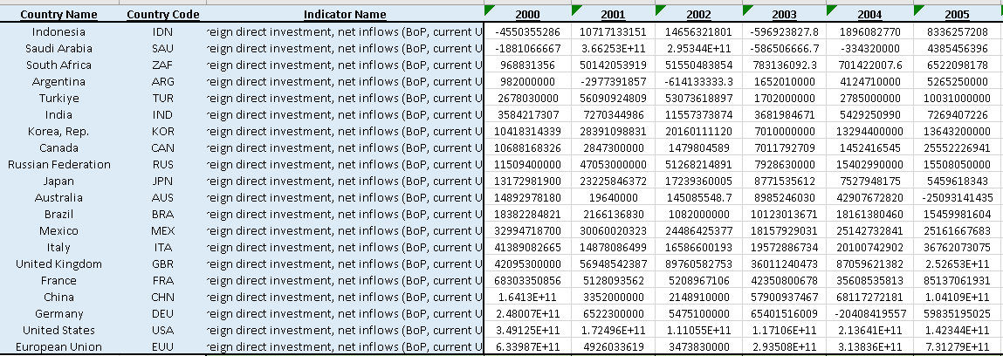

Statistical Analysis:

Graph Plotting:
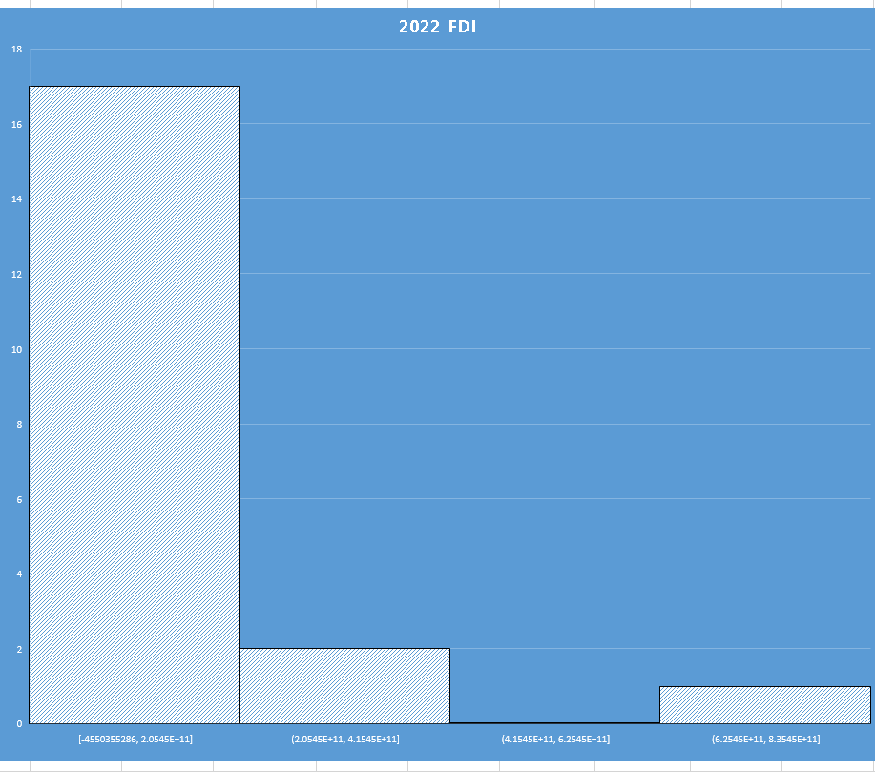

Fig. 7) Annual Foreign Investment all countries in 2022

Discussion on Results:
Excel was used as a tool to carry out analysis on the given raw data using some excel formulas on each column which was year attribute for all countries given in the data

Mathematical Formulas:
Mean = AVERAGE(D2:D21)
Median = MEDIAN(D2:D21)
Variance = VAR.P(D2:D21)
Standard Deviation =STDEV.P(D2:D21)

Graphical Analysis:
In fig. 7 the histogram’s first bar shows the investment given to 17 countries in 2022 is in majority and only two countries are given heavy investment.

Task2:
Raw Data given consisting of years, actual data/ input y and 4 models applied (PRNN ,AR,SVM & ENSEMBLE) and given 4 outputs(y`)

Raw Data:
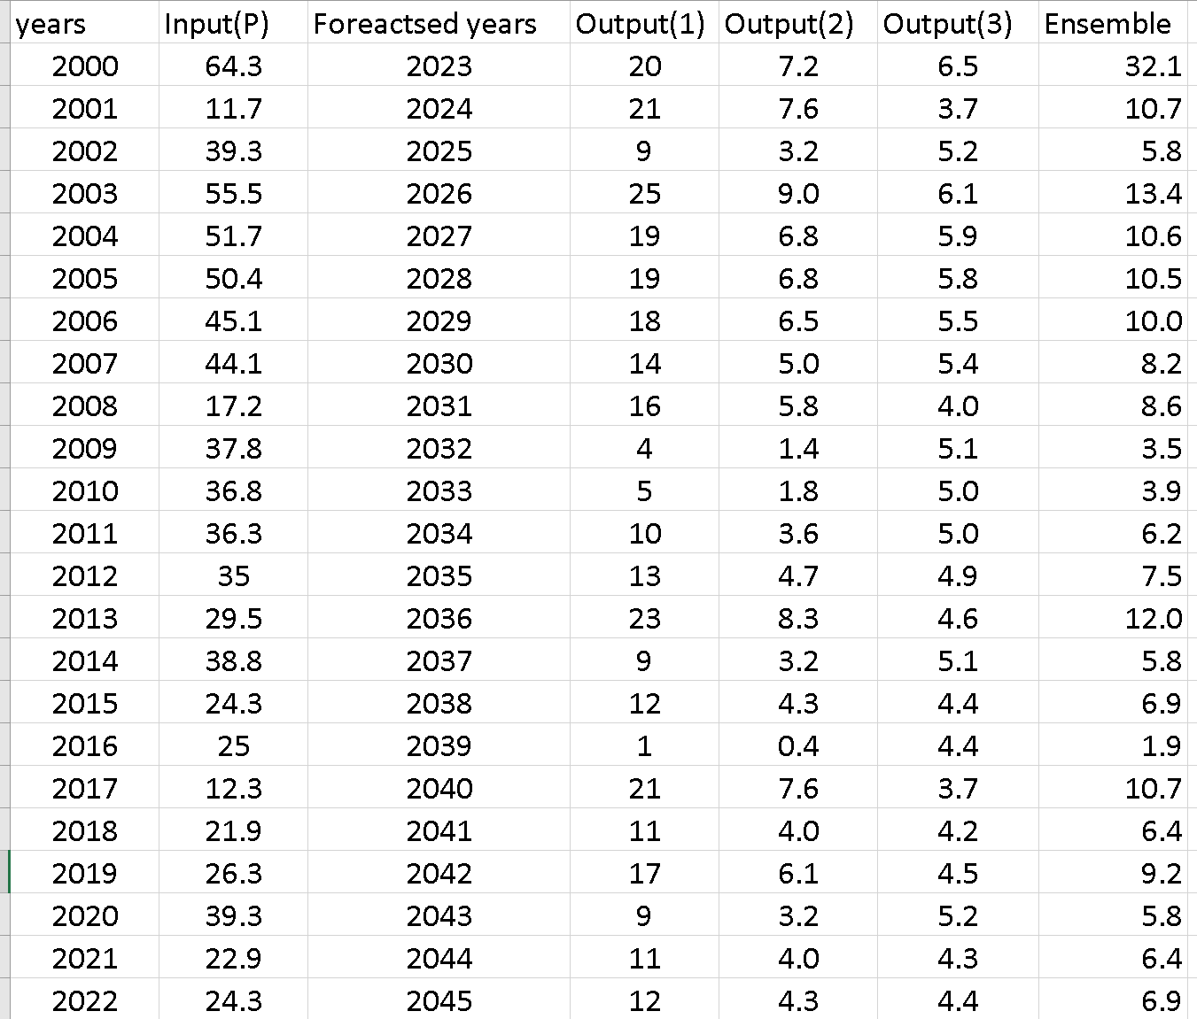

Model Diagram:
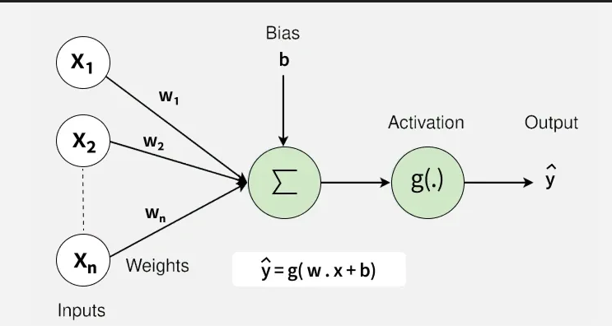
Error Computation:
Three error computation for 4 models are:
- MAE(Mean absolute error)
- RMSE(root mean square error)
- NMAE(Normalized mean absolute error)
Mathematical Formulas:
In excel the errors were calculated using following formulas:
MAE=AVERAGE(ABS(A1:A10-B1:B10))
RMSE=SQRT(AVERAGE((A1:A10-B1:B10)^2))
NMAE= AVERAGE(ABS(A1:A10-B1:B10))/AVERAGE(A1:A10) *100

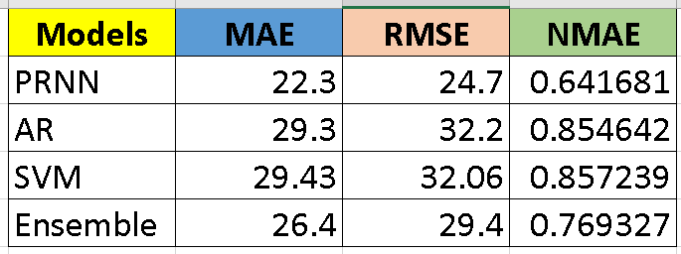

Graphical Plotting:
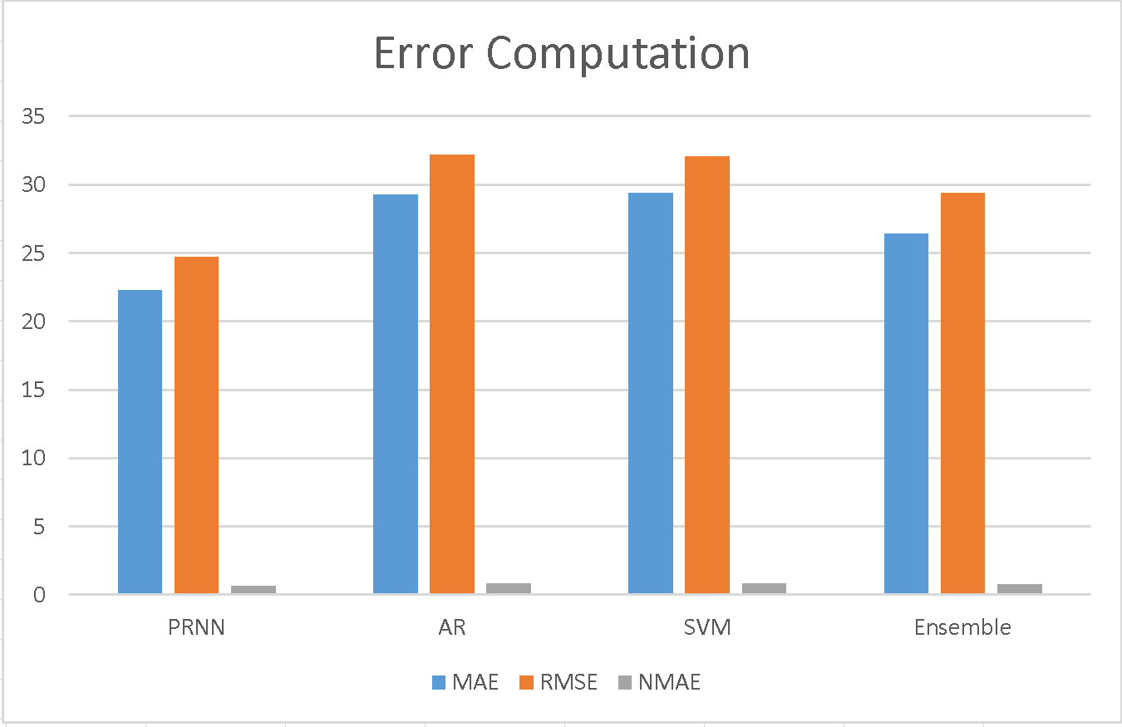
Fig. 8) Error Computation

Discussion on Results(Conclusions):

From the bar graph of fig. 8, It can be observed that the PRNN model method is the giving minimum error which means more accuracy in the model output.

Second best method is Ensemble average, therefore after comparing all models we conclude that we will adopt PRNN for this study with data of future coming years.

Task 3:
Raw Data given consisting of y input (actual data) and 1 model PRNN applied, given 1 output(y`), Find following errors and plot the graph:

Error Computation:
Six errors to compute are:
- MAE (Mean absolute error)
- RMSE (root mean square error)
- NMAE (Normalized mean absolute error)
- MSE (Mean square error)
- RSQ (root square error)
- MAPE (mean absolute percentage error)

Mathematical Formulas:
In excel the errors were calculated using following formulas:

MAE= AVERAGE(ABS(A1:A10-B1:B10))
RMSE= SQRT(AVERAGE((A1:A10-B1:B10)^2))
NMAE= AVERAGE(ABS(A1:A10-B1:B10))/AVERAGE(A1:A10) *100
MSE= AVERAGE((A1:A10-B1:B10)^2)
RSQ= RSQ(Y,Y`)
MAPE=AVERAGE(ABS((A1:A10-B1:B10)/(A1:A10)))*100

Raw Data:
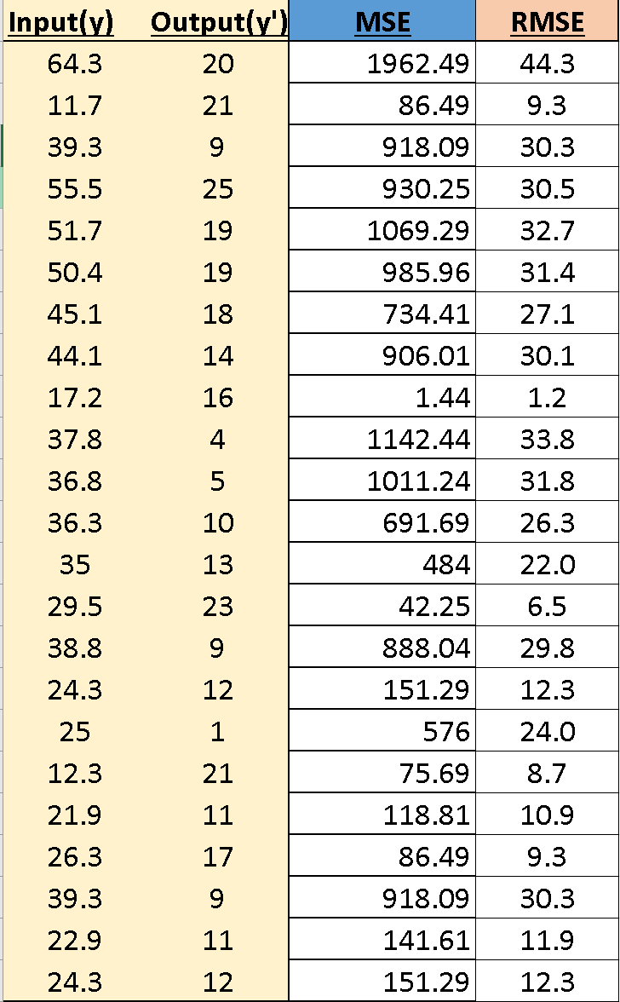

Model Diagram:

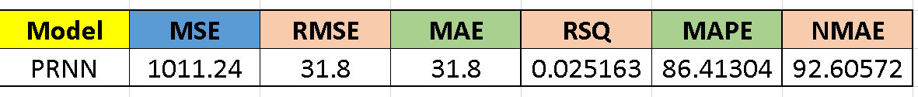

Graphical Plotting:
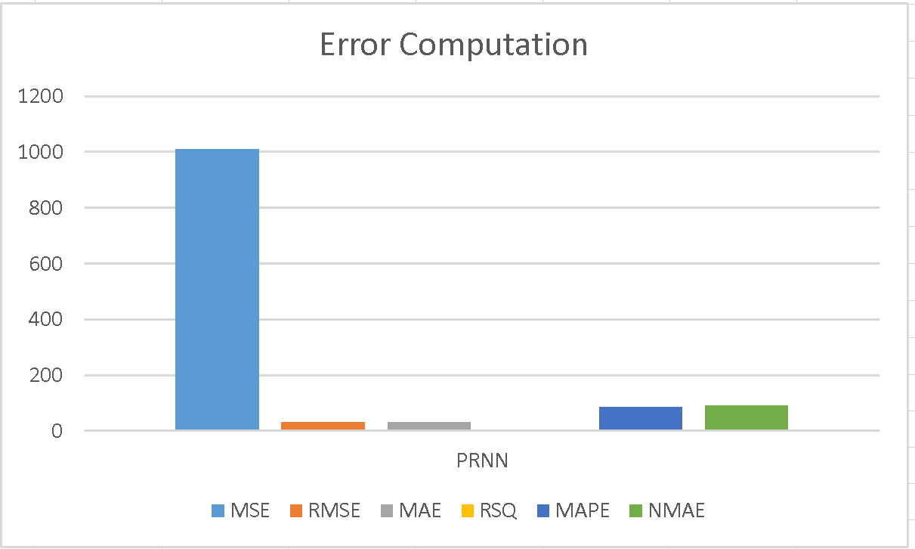
Fig. 9) Error Computation

Discussion on Results(Conclusions):

From the bar graph of fig. 9, Error Computation” shows the performance evaluation of a predictive model called PRNN (probably “Probabilistic Recurrent Neural Network” or “Parallel Recurrent Neural Network”) using several error metrics. It can be observed that the PRNN model method is the giving maximum error for raw data on MSE but its square RMSE and MAE is moderate and its RSQ is almost nothing, NMAE AND MAPE are small, which means more accuracy in the model output when reduce error using RSQ.

-----------------------------------------------------------------------

